Name **Nuzhat Qureshi**

Roll No BIT-24S-029

Github link [NuzhatQureshi90/Pythons-lab-manual-IT-A-: Python lab manuals](https://github.com/NuzhatQureshi90/Pythons-lab-manual-IT-A-)

**LAB MANUAL # 01**

**TASK 01**

Q-1 Make 2-2 programs of each datatype.

1. **NUMERIC TYPES:**

* Integer:

Program:

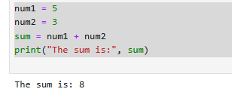

Program:

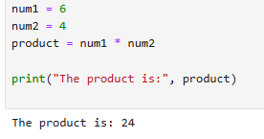

* Float:

Program:

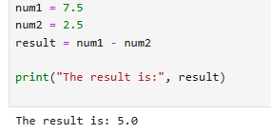

Program:

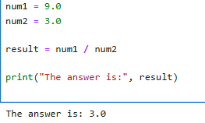

* Complex:

Program:

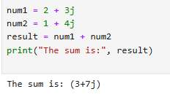

Program:

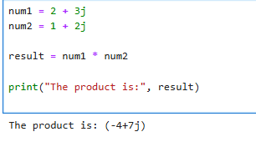

1. **SEQUENCE TYPES:**

* String

Program:

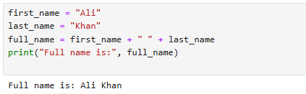

Program:

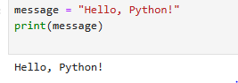

* List:

Program:

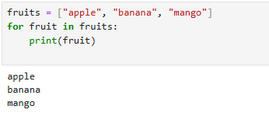

Program:

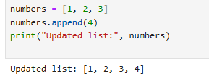

* Tuple:

Program:

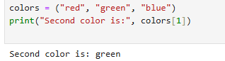

Program:

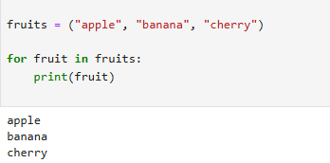

* Range:

Program:

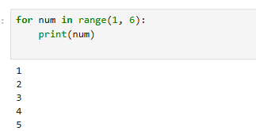

Program:

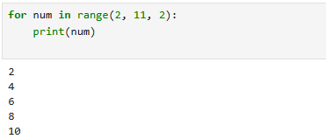

1. **SET TYPES:**

Program:

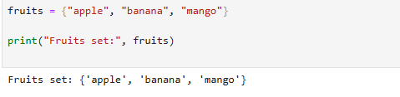

Program:

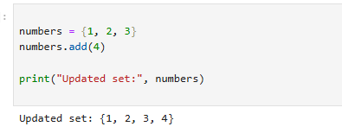

* **Frozen set:**

Program:

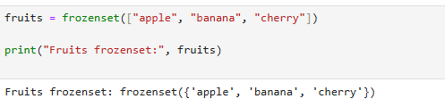

Program:

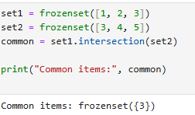

**MAPPING TYPE:**

* Dictionary dict:

Program:

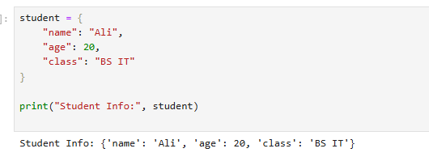

Program:

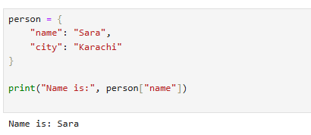

**BOLEAN TYPE**:

**Program:**

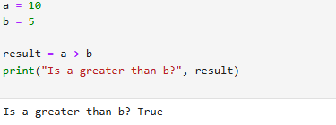

Program:

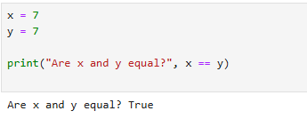

**TASK NO 02:**

Q.2 Make up to 5 shapes programs using *

Programs:

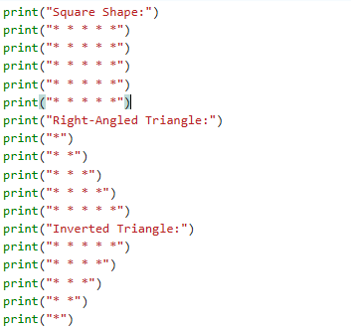

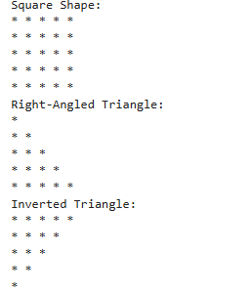

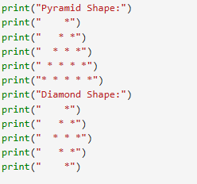

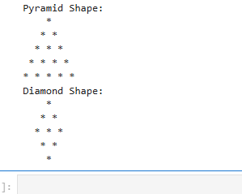

**TASK 03**

Q.3 Make same shapes you have made in task 2,using * multiple by number.

Program:

